
CosmiCode
Artificial Intelligence
Internship Module
Week 1 – Introduction to AI & Python for AI (Beginner)

Submitted To: Zarwish – CosmiCode HR
Submitted By: Haris Ali
Subject: Artificial Intelligence
Internship Module: Week 1
Date of Submission: 20/06/2025

Objective: Understand AI fundamentals and basic Python programming for AI applications.
Tasks:
- Write a note (300 words) explaining What is AI?, types of AI, and its real-world applications.
SOLUTION:
What is AI?
Artificial Intelligence, or AI, is the ability of machines or computer programs to think and learn like humans. It means that a computer can do tasks that normally need human intelligence—like understanding language, recognizing images, solving problems, or making decisions.
AI is based on data. It learns from data to improve its performance over time. For example, if you search something on Google, AI tries to give you the best answer based on what it learned from millions of searches.
Types of AI
There are mainly three types of AI:
- Narrow AI (Weak AI):
This type of AI is designed to do a specific task. It cannot do anything beyond that. Examples include virtual assistants like Siri or Alexa, recommendation systems on Netflix or YouTube, and chatbots.
- General AI (Strong AI):
This AI can think, understand, and make decisions just like a human. It can perform any task a person can do. We are still working towards achieving General AI in real life.
- Super AI:
This is a future type of AI that will be smarter than humans in every way. It is only a concept right now and does not exist yet.

Real-World Applications of AI
- Healthcare: AI helps doctors detect diseases early, like cancer, by analyzing medical images and data.
- Finance: Banks use AI to detect fraud and manage financial risks.
- Transportation: Self-driving cars use AI to recognize roads, signs, and avoid accidents.
- Education: AI-based tools help students learn better by giving personal suggestions.
- E-commerce: Online stores like Amazon use AI to recommend products you might like.

- Install Python, Jupyter Notebook, and essential libraries (NumPy, Pandas, Matplotlib, Seaborn).
First install libraries :
pip install numpy pandas matplotlib seaborn
SOLUTION:
Then test libraries:
import numpy as np
import pandas as pd
import matplotlib.pyplot as plt
import seaborn as sns
data = pd.DataFrame({
'x': np.arange(1, 11),
'y': np.random.randint(10, 100, size=10)
})
sns.barplot(x='x', y='y', data=data)
plt.title("Sample Bar Plot")
plt.show()
OUTPUT:
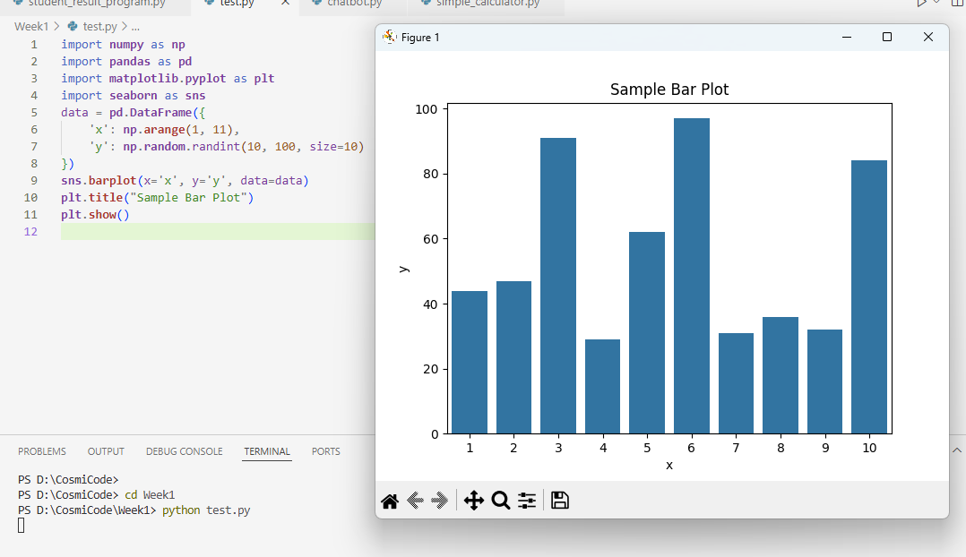

- Create a program to input student details and display results using if-else and loops.
SOLUTION:
num_students = int(input("Enter number of students: "))
for i in range(num_students):
print(f"\n--- Enter details for Student {i+1} ---")
name = input("Enter student's name: ")
roll_no = input("Enter roll number: ")
marks1 = float(input("Enter marks of English: "))
marks2 = float(input("Enter marks of Urdu: "))
marks3 = float(input("Enter marks of Math: "))
total = marks1 + marks2 + marks3
percentage = (total / 300) * 100
if percentage >= 90:
grade = 'A+'
elif percentage >= 80:
grade = 'A'
elif percentage >= 70:
grade = 'B'
elif percentage >= 60:
grade = 'C'
elif percentage >= 50:
grade = 'D'
else:
grade = 'F'
print("\n--- Result ---")
print(f"Name: {name}")
print(f"Roll No: {roll_no}")
print(f"Total Marks: {total}/300")
print(f"Percentage: {percentage:.2f}%")
print(f"Grade: {grade}")
OUTPUT:
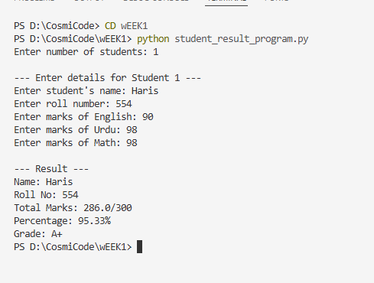
- Create a simple chatbot using if-else conditions (rule-based bot).
SOLUTION:
print("🤖 ChatBot: Hello! I'm a simple chatbot. Try saying 'hi', 'help', or 'bye'.\n")
commands = {
'greetings': ["hi", "hello", "hey"],
'feelings': ["how are you", "how's it going"],
'identity': ["your name", "who are you"],
'time': ["time", "what time is it"],
'date': ["date", "today's date"],
'help': ["help", "what can you do"],
'exit': ["bye", "goodbye", "exit"]
}
current_hints = ["Try saying 'hi' to start!"]
while True:
print(f"\n💡 Hint: {current_hints[0]}")
user_input = input("You: ").lower()
if any(word in user_input for word in commands['greetings']):
print("🤖 ChatBot: Hello there!")
current_hints = [
"Ask 'how are you?'",
"Try asking 'what's your name?'",
"Say 'help' to see options"
]
elif any(phrase in user_input for phrase in commands['feelings']):
print("🤖 ChatBot: I'm just a program, but I'm functioning well!")
current_hints = [
"Ask 'what time is it?'",
"Try asking 'today's date?'"
]
elif any(phrase in user_input for phrase in commands['identity']):
print("🤖 ChatBot: I'm SimpleBot, your rule-based assistant!")
current_hints = [
"Say 'help' to see what I can do",
"Try asking about the time or date"
]
elif any(word in user_input for word in commands['time']):
from datetime import datetime
print(f"🤖 ChatBot: The current time is {datetime.now().strftime('%H:%M')}")
current_hints = ["Ask about today's date", "Say 'help' for options"]

elif any(word in user_input for word in commands['date']):
from datetime import datetime
print(f"🤖 ChatBot: Today is {datetime.now().strftime('%Y-%m-%d')}")
current_hints = ["Ask what time it is", "Say 'your name'"]

elif any(word in user_input for word in commands['help']):
print("🤖 ChatBot: I can respond to:")
print("- Greetings (hi, hello)")
print("- How you're feeling")
print("- Tell you my name")
print("- Give current time/date")
current_hints = ["Try any of these commands now!"]

elif any(word in user_input for word in commands['exit']):
print("🤖 ChatBot: Goodbye! Have a nice day!")
break

else:
print("🤖 ChatBot: I didn't understand that.")
current_hints = [
"Try saying 'help' to see options",
"Basic commands: hi, time, date, bye"
]
OUTPUT:
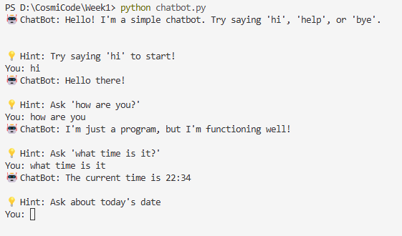
- Write a Python program to perform basic math operations using functions.
SOLUTION:
def add(x, y):
"""Addition function"""
return x + y

def subtract(x, y):
"""Subtraction function"""
return x - y

def multiply(x, y):
"""Multiplication function"""
return x * y

def divide(x, y):
"""Division function"""
if y == 0:
return "Error! Division by zero."
return x / y

def power(x, y):
"""Exponentiation function"""
return x ** y

def modulus(x, y):
"""Modulus/remainder function"""
if y == 0:
return "Error! Division by zero."
return x % y

def calculator():
"""Main calculator function"""
print("\nBasic Math Operations Calculator")
print("1. Addition (+)")
print("2. Subtraction (-)")
print("3. Multiplication (*)")
print("4. Division (/)")
print("5. Exponentiation (^)")
print("6. Modulus (%)\n")

while True:
try:
choice = input("Enter operation number (1-6) or 'q' to quit: ")

if choice.lower() == 'q':
print("Exiting calculator...")
break

if choice not in ['1', '2', '3', '4', '5', '6']:
print("Invalid input! Please enter a number between 1-6.")
continue

num1 = float(input("Enter first number: "))
num2 = float(input("Enter second number: "))

if choice == '1':
print(f"Result: {num1} + {num2} = {add(num1, num2)}")
elif choice == '2':
print(f"Result: {num1} - {num2} = {subtract(num1, num2)}")
elif choice == '3':
print(f"Result: {num1} * {num2} = {multiply(num1, num2)}")
elif choice == '4':
print(f"Result: {num1} / {num2} = {divide(num1, num2)}")
elif choice == '5':
print(f"Result: {num1} ^ {num2} = {power(num1, num2)}")
elif choice == '6':
print(f"Result: {num1} % {num2} = {modulus(num1, num2)}")

except ValueError:
print("Invalid input! Please enter numeric values.")
except Exception as e:
print(f"An error occurred: {e}")

if __name__ == "__main__":
calculator()
OUTPUT:
